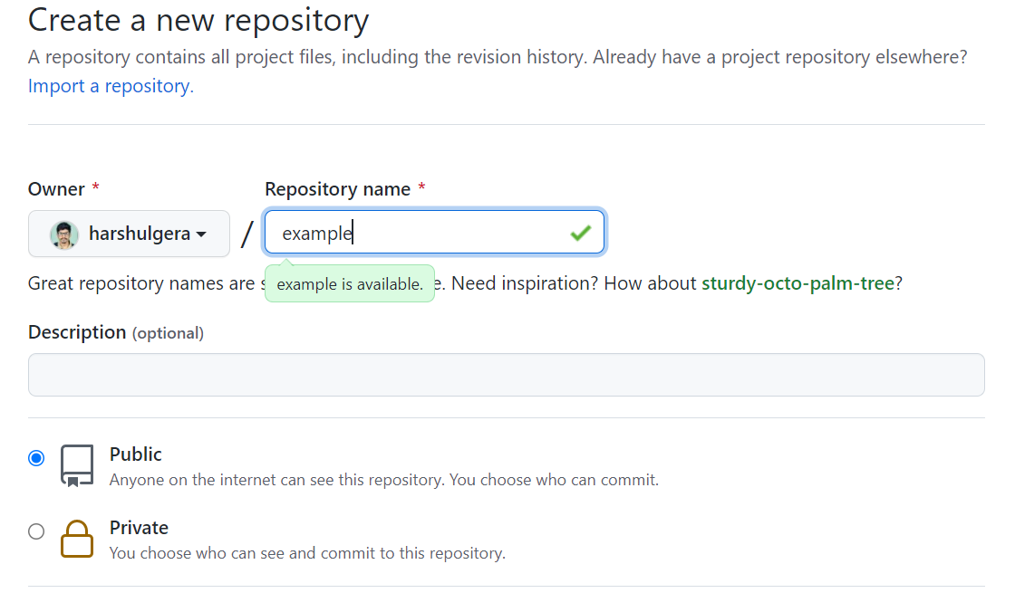

git init- Initialize a new Git Repository on Working Directory

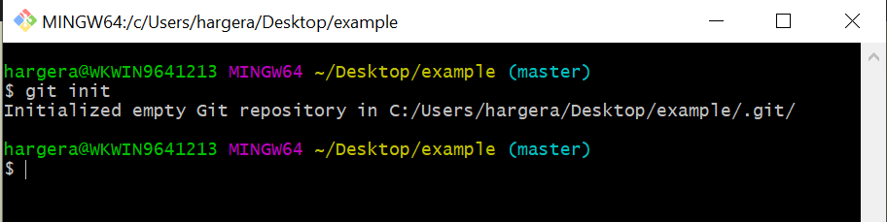

git remote add origin- Creates a connection between working directory & git repository(in which we want to work)



git status- Tells about the untacked files, commits status, etc

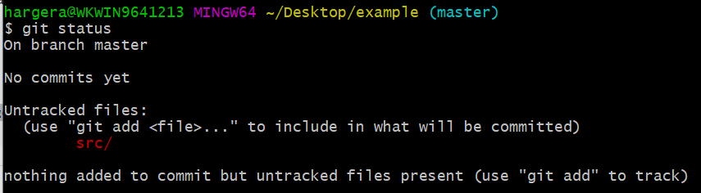

git add <File Name or ‘.’ > - Add files to staging area



git commit -m “<Message>” – Commits the staging area and transfers to git repository(local)

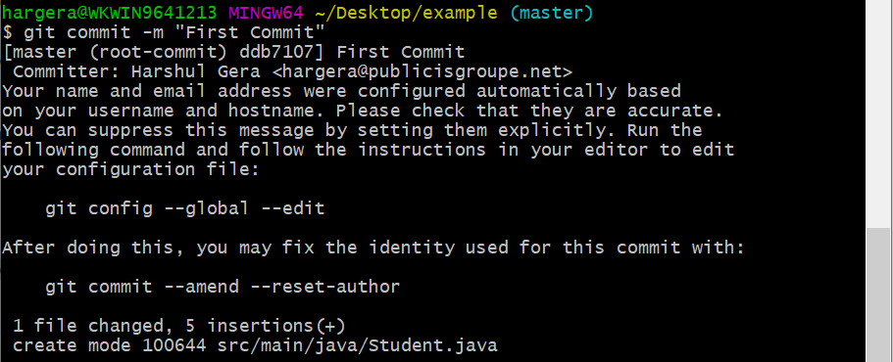

Cat- displays file contents

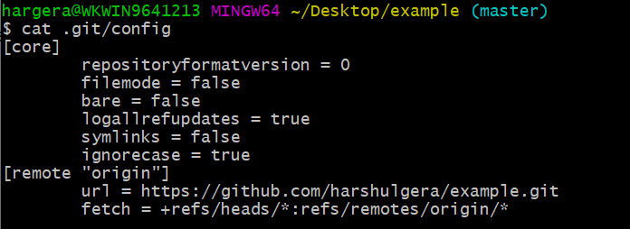

git push- update the remote git repository from remote repository

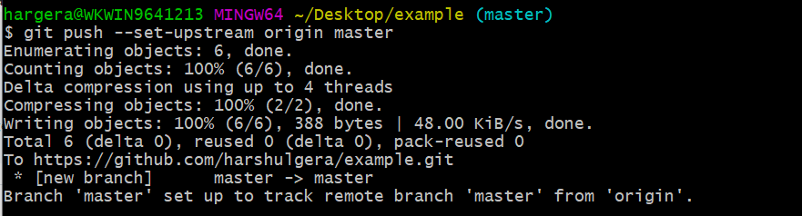

git push- update the local git repository from local repository

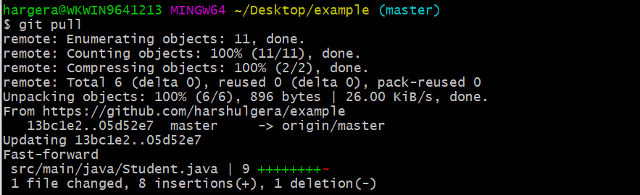

git log – Gives description of different commits made until now

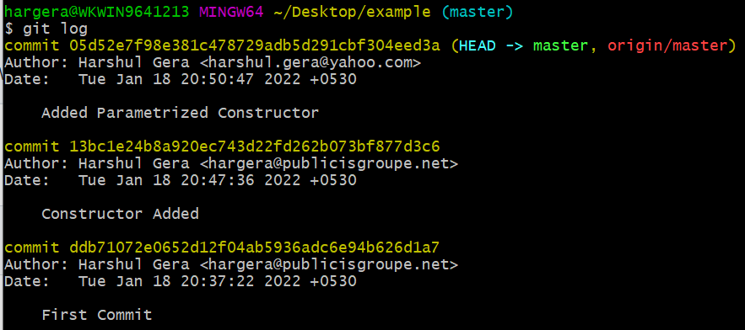

git branch- displays the current branch in use

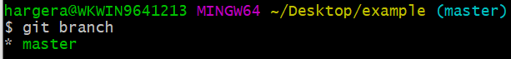

git branch <branch name>- creates a new branch



git checkout <branch name>- switches the current branch to specified branch name

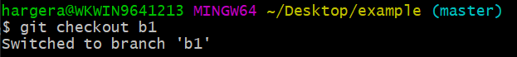

git checkout -b <branch name>- Creates a new branch & switches the current branch to new branch

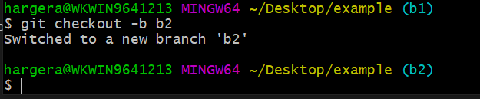

git branch –list – Lists all the branches in Repository && highlights the current branch being used

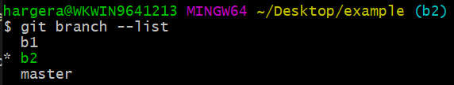

git merge <branch name> - Merge the branch name specified into current branch

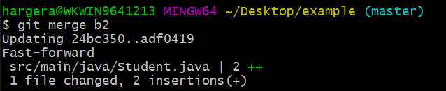

git branch -d <branch name> - Deletes the specified branch name

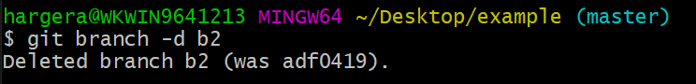

git clone <url> - Clones the Working Directory from Git Repository URL

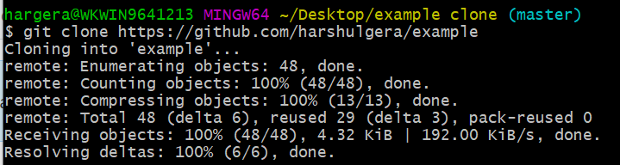

git diff <commit1> <commit2> - Tells the difference between two different commits

